**INTERNET OF THINGS**

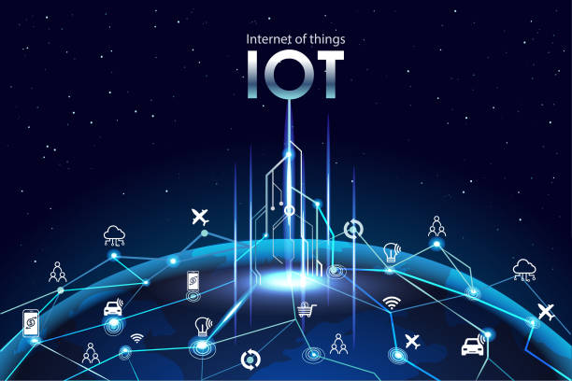 **FLOOD MONITORING SYSTEM**

**INTRODUCTION:**

**In the face of escalating climate-related challenges, the development of a robust Flood Monitoring System emerges as a pivotal initiative. This system represents a sophisticated integration of cutting-edge technologies to address the increasing threats posed by flooding incidents. This introduction sets the stage for an exploration into the multifaceted components of the system, emphasizing its pivotal role in enhancing preparedness, minimizing damages, and ultimately fostering a more resilient response to the ever-growing risk of floods.**

**ABSTRACT:**

**The flood monitoring system is a crucial technological solution designed to enhance early detection and response to flooding events. Utilizing a network of sensors, data analytics, and real-time communication, this system aims to continuously monitor water levels, weather patterns, and potential flood risks. By employing advanced algorithms, it provides accurate predictions and timely alerts to authorities and affected community.**

**PROJE CT DEFITITION:**

**As we all know that Flood is one of the major well known Natural Disasters. When water level suddenly rises in dams, river beds etc. Alot of Destruction happens at surrounding places. It causes a huge amount of loss to our environment and living beings as well. So in these case, it is very important to get emergency alerts of the water level situation in different conditions in the river bed.**

**The purpose of this project is to sense the water level in river beds and check if they are in normal condition. If they reach beyond the limit, then it alerts people through LED signals and buzzer sound. Also it alerts people through Sms and Emails alerts when the water level reaches beyond the limit.**

**PROJECT OBJECTIVES:**

**Real-time flood monitoring objectives typically include:**

**1. Early Warning: Detecting flood events as they occur or even before they happen to provide early warnings to residents, emergency responders, and authorities.**

**2. Data Collection: Gathering real-time data on rainfall, river water levels, weather conditions, and other relevant parameters to assess flood risk.**

**3. Risk Assessment: Assessing the severity and potential impact of flooding in specific areas based on collected data.**

**4. Decision Support: Providing decision-makers with timely and accurate information to make informed choices about evacuation, resource allocation, and flood mitigation strategies.**

**5. Public Safety: Protecting lives and property by alerting residents to evacuate or take precautionary measures during a flood event.**

**These objectives collectively aim to reduce the impact of flooding on communities and enhance disaster preparedness and response efforts.**

**IOT SENSOR NETWORK DESIGN:**

**Deploying IoT sensors to monitor water levels involves several steps:**

1. **Sensor Selection : Appropriate water level sensors based on your specific requirements. Options include ultrasonic sensors, pressure sensors, or capacitive sensors, depending on the application.**
2. **Data Communication: Select a communication protocol (e.g., Wi-Fi, LoRa, cellular) and gateway devices to transmit data from the sensors to a central server or cloud platform.**
3. **Power Supply: Ensure a reliable power source for the sensors, which can be batteries, solar panels, or even energy harvesting methods, depending on the deployment location.**
4. **Sensor Placement: Strategically install sensors at key locations, such as rivers, reservoirs, or flood-prone areas. Consider factors like accessibility and environmental conditions.**
5. **Data Processing: Set up a central server or cloud platform to receive and process sensor data. Implement data analytics to detect trends, anomalies, or potential issues.**
6. **Alert System: Develop an alert system that can notify relevant stakeholders in real-time when water levels reach critical thresholds or unusual patterns are detected.**
7. **Data Visualization: Create user-friendly dashboards or mobile apps to visualize water level data for easy monitoring and decision-making.**
8. **Security: Implement robust security measures to protect the IoT network from cyber threats and unauthorized access.**
9. **Maintenance: Establish a maintenance schedule for sensor calibration, battery replacement, and system updates to ensure long-term reliability.**
10. **Data Storage: Store historical data for analysis and future reference. Consider data retention policies and compliance requirements.**

**Continuous monitoring of water levels using IoT sensors can help prevent disasters like floods, manage water resources efficiently, and protect the environment.**

**EARLY WARNING PLATFORM**

* **AquaMonitor is a user-friendly web-based platform designed for real-time visualization and monitoring of water levels across various locations. This innovative system provides a comprehensive solution for users ranging from local authorities to concerned citizens, offering crucial insights into water level dynamics to facilitate informed decision-making and early response to potential flood events.**
* **AquaMonitor represents a leap forward in flood monitoring technology, offering a dynamic and accessible platform for tracking water levels in real time. By combining advanced data visualization with user-friendly features, this web-based system empowers stakeholders at various levels to proactively manage flood risks and enhance community resilience in the face of changing environmental conditions.**

**INTEGRITY APPROACH:**

**IoT sensors can send data to an early warning system through a structured process that involves sensor deployment, data collection, and transmission. Here’s a general overview of how this connection is established:**

**1. Sensor Deployment:**

**- Deploy IoT sensors strategically in flood-prone areas, water bodies, or relevant locations. These sensors are equipped with various environmental monitoring capabilities, such as water level sensors, rain gauges, or weather sensors.**

**2. Data Collection:**

**- IoT sensors continuously collect data from the environment based on their specific monitoring functions. For flood monitoring, this could include data on water levels, precipitation, temperature, and other relevant parameters.**

**3. Data Processing and Aggregation:**

**- The collected data is processed within the IoT devices to ensure accuracy and relevance. Aggregated data may include real-time measurements, historical trends, and any anomalies detected by the sensors.**

**4. Communication Protocols:**

**- IoT sensors use communication protocols such as MQTT (Message Queuing Telemetry Transport), HTTP/HTTPS, or CoAP (Constrained Application Protocol) to transmit the collected data. The selection of the protocol depends on factors like energy efficiency, data volume, and network constraints.**

**5. Connectivity:**

**- IoT sensors typically use wireless communication technologies like Wi-Fi, cellular networks, LoRa (Long Range), NB-IoT (Narrowband IoT), or satellite communication to connect with the broader network.**

**6. Gateway Devices:**

**- In some cases, IoT sensors may communicate directly with the early warning system. However, in more extensive deployments, gateway devices might be employed to aggregate data from multiple sensors and transmit it collectively to the central system.**

**7. Cloud-Based Platforms:**

**- The transmitted data is often sent to cloud-based platforms or edge computing systems for further processing and storage. These platforms can handle large volumes of data, perform analytics, and ensure data integrity.**

**8. Integration with Early Warning System:**

**- The early warning system is designed to receive, process, and analyze incoming data. It may use APIs (Application Programming Interfaces) or specific protocols to integrate seamlessly with the IoT platform.**

**9. Alert Generation:**

**- Based on the analyzed data, the early warning system triggers alerts when predefined thresholds or abnormal patterns are detected. These alerts can be sent through various channels such as SMS, email, mobile apps, or sirens, depending on the urgency and severity of the situation.**

**10. User Interface:**

**- The early warning system provides a user interface, such as a web-based dashboard or a mobile app, where users can visualize real-time data, historical trends, and receive alerts. This interface is critical for decision-makers, emergency responders, and the public.**

**By following this process, IoT sensors seamlessly contribute to the early warning system, enhancing its capability to provide timely and accurate alerts for flood events.**